Award of Distinguished Member Status to Colin Farmer

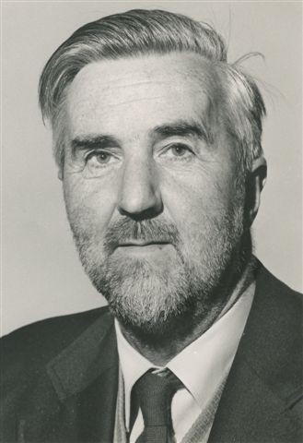

The AluSiV meeting held from the 3rd-5th September 2008 at the Macaulay Institute, was conceived as a tribute to Colin Farmer (1920-2006) who, with the exception of a short period immediately after his retirement in 1983, spent all his working life at the Macaulay Institute in Aberdeen, Scotland. Colin made major contributions to our understanding of the mineralogy and chemistry of aluminium and silicon in soils, as well as pioneering the use of infrared spectroscopy in the identification, characterization and reactivity of the amorphous or poorly crystalline secondary minerals involved. Under the title ’AluSiV’ the Clay Minerals Group of the Mineralogical Society of Great Britain & Ireland and the British Society of Soil Science endeavoured to bring together a conference that would be wide ranging from the nano to the landscape scale; where interactions between chemistry, mineralogy and biology would be the link between these scales; and where the importance of cutting-edge analytical methods would be apparent.
Jim Russell, who was a close colleague of Colin’s over several decades, opened the meeting with a ‘A tribute to Victor Colin Farmer’ (download a podcast of this from http://www.minersoc.org/pages/groups/cmg/alusiv-archive.html). Jim described how the first IR spectrometer was obtained at the Macaulay in 1954 and how quickly Colin mastered the reading of IR spectra.
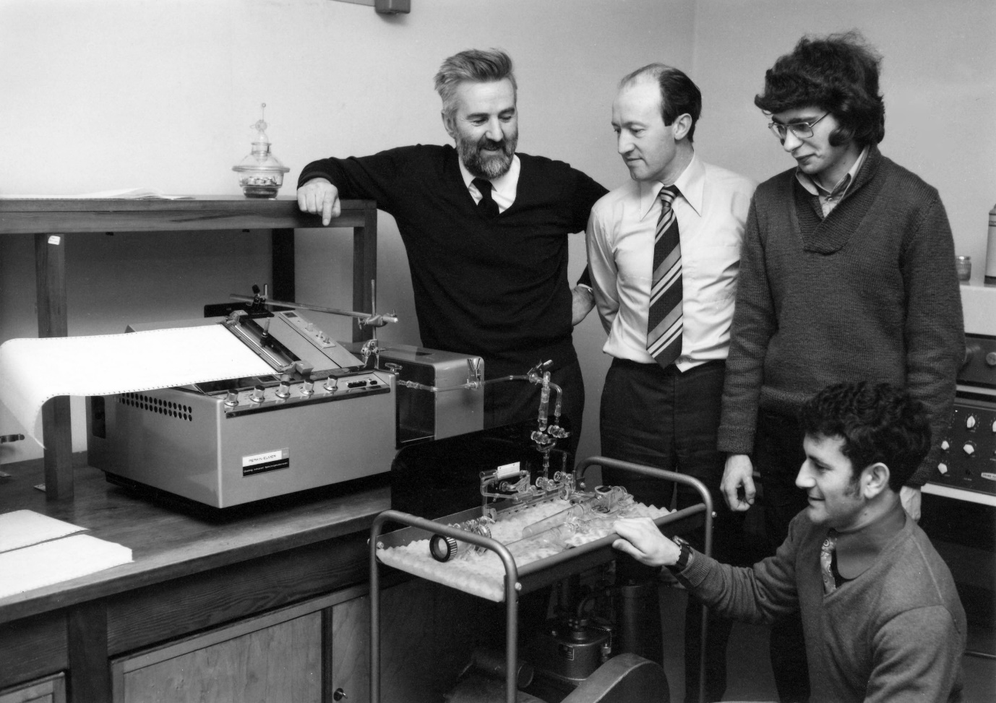

Colin Farmer, Jim Russell, Ian Black and Tony Fraser (kneeling) with a new infrared spectrometer. Circa 1970.

He went on to describe how a paper with Bruce Mitchell in 1962 was the first lead into Colin’s pioneering work on imogolite and the importance of amorphous minerals in soils.

