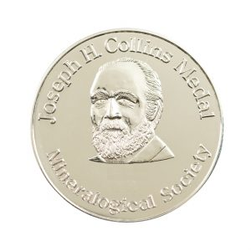

Collins Medal
Awards Committee voting form

Your task as a member of the awards committee is to consider each nomination on its merits, using each of the criteria listed below. We have applied this voting scheme to move the Society away from an over-reliance on published work as the main evidence of excellence though it is retained as an important factor.

Choose a ‘score’ for the candidate in each of the categories shown below. To the score for A (Impact), add your top four scores from among the other six categories.

Example:
 | Criteria | Score Maximum | Score awarded by you, the judge | Selected scores (A, plus four others)
A | Impact of nominee’s work | 24 | 19 | 19
B | Publications | 19 | 14 | 14
C | Service to industry | 19 | 5 | -
D | Outreach/promotion of science | 19 | 15 | 15
E | Leadership/Service | 19 | 10 | 0
F | Teaching | 19 | 12 | 12
G | EDI activities | 19 | 16 | 16
 |  |  |  | Final Score: | 76

Purpose
‘The Collins Medal will be awarded annually to a scientist who, during a long and active career, has made an outstanding contribution to applied mineralogy, clay mineralogy, environmental mineralogy, geochemistry, geomicrobiology, metamorphism, mineral physics or vocanology and magmatic studies, reflecting the diverse and worldwide interests and membership of the Society. Evidence of such excellence should be in the form of the impact of the applicant’s/nominee’s work, their publications, service to industry, outreach/promotion of science, leadership or other service to the community, teaching and work to improve equality, diversity and inclusivity in our science. Nominees/applicants do not have to be Members of the Mineralogical Society or nationals of the UK or Ireland.

Eligibility
The candidates have been invited to note any personal circumstances which they wish to be taken into consideration when evaluating their nomination (e.g. caring responsibilities, periods of family leave, bereavement, ill health or disability). You should take into account the impact of these circumstances on their career.

There is a table for each candidate.

 | Criteria | Score Maximum | Score awarded by you, the judge | Selected scores (A, plus four others)
A | Impact of nominee’s work | 16
B | Publications | 14
C | Service to industry | 14
D | Outreach/promotion of science | 14
E | Leadership/Service | 14
F | Teaching | 14
G | EDI activities | 14
 |  |  |  | Final Score:

When you have completed your scoring for each candidate, you should rank all of the candidates in order of preference, with 5 for your most favoured candidate (where there are five nominees/applicants), 1 for your least favoured candidate and 0 for any ineligible candidates.

Candidate | Ranking
Candidate A
Candidate B
Candidate C
Candidate E
Candidate F

