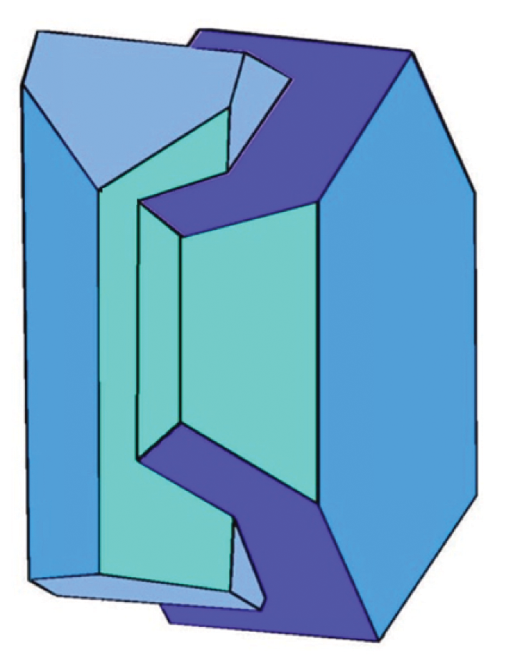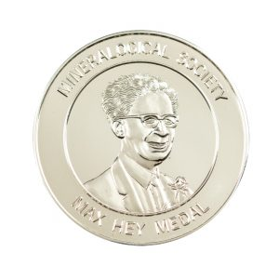

# Nomination form for Mineralogical Society Awards

# Max Hey Medal

### Purpose

‘To recognise existing and ongoing excellence in applied mineralogy, clay mineralogy, environmental mineralogy, geochemistry, geomicrobiology, metamorphism, mineral physics or volcanology and magmatic studies,reflecting the diverse and worldwide interests and membership of the Society. Evidence of such excellence should be in the form of the impact of the applicant’s/nominee’s work, their publications, service to industry, outreach/promotion of science, leadership or other service to the community, teaching and work to improve equality, diversity and inclusivity in our science.

### Eligibility

On the closing date for applications/nominations, candidates must be within 15 years of the award of their first degree, with allowances for ‘Contextual Factors’*, in which case the committee chair may agree to accept applications/nominations for candidates for whom the first degree was awarded more than 15 years previously.’ If you would like to check eligibility, please contact the Executive Director – kevin@minersoc.org, the chair of the Awards Committee or the chair of the EDI committee (email addresses given in the Committees page: <https://www.minersoc.org/personnel.html>).

* If you feel that there are any personal circumstances which you wish to be taken into consideration when evaluating your nomination (e.g. caring responsibilities, periods of family leave, bereavement, ill health or disability), please do so, giving details of the impact on your/the nominee’s career.

Nominations should consist of a completed form (written in the third person, in order that self-nominations and third-party nominations cannot be distinguished by the Awards committee) and a copy of the nominee’s CV.

Nominations will remain on the table for three years. Previous recipients of the award, Society Officers, members of Council and members of the Committee (at the time of nomination and adjudication) will not be eligible for the award.

|  |  |
| --- | --- |
| Name of nominee/applicant: |  |
| Address: |  |
| E-mail address: |  |

Signature:

|  |
| --- |
| A. Describe the impact of the applicant’s/nominee’s work (this will help to summarize the effect of the work of the applicant/nominee under the categories described in the rest of the form) (1400 characters) |
|  |
| **B. List 5 key publication (feel free to include information about downloads/citations here)** (1400 characters) |
|  |
| C. Service to Industry (1400 characters) |
|  |
| **D. Outreach/promotion of our science** (1400 characters) |
|  |
| **E. Leadership or other service to the community** (1400 characters) |
|  |
| **F. Teaching** (1400 characters) |
|  |
| **G. Work to improve Equality, Diversity and Inclusivity in our science** (1400 characters) |
|  |

*I certify that, to the best of my knowledge, the person I have nominated has not been sanctioned or found at fault as the result of a complaint, investigation, or other proceeding related to their professional conduct (including harassment allegations), and that they are not currently the subject of such an investigation.*

*I am aware that the person I have nominated has been sanctioned or found at fault as the result of a complaint, investigation, or other proceeding related to their professional conduct, or that they are is currently the subject of such an investigation but would nevertheless like to proceed with the nomination. (Please note that selecting the second case is not necessarily disqualifying, but you may be contacted for a confidential discussion.)*