Thermodynamics Exercise 3 solutions

1. Balance the following reactions assuming K+, H+ and H4SiO4 in solution :

a) KAlSi3O8 = KAl3Si3O10(OH)2

Feldspar Muscovite

**3KAlSi3O8 +2H+ + 12H2O=KAl3Si3O10(OH)2 + 2K+ +6H4SiO4o**

b) KAl3Si3O10(OH)2 = Al2Si2O5(OH)4

Muscovite Kaolinite

**2KAl3Si3O10(OH)2 +2H++ 3H2O = 3Al2Si2O5(OH)4 +2K+**

2) At 298K the breakdown of K-feldspar KAlSi3O8 in solution may produce Kaolinite or Muscovite

a) Plot equilibrium between K-feldspar and Kaolinite on a diagram of Log([K+]/[H+]) versus Log([H4SiO4]) given :-

2H+ + 2KAlSi3O8 + 9H2O = Al2Si2O5(OH)4 + 2K+ + 4H4SiO4

Fspar Kaolinite

Go = + 41450J ( with activities of solids and of water being 1.0)

**At 298 K, Log K= -Go/(2.303R.298)=2log([K+]/[H+])+4log[H4SiO4o]**

**2log([K+]/[H+])+4log[H4SiO4o]=-7.26**

**So our line has log([K+]/[H+])=-3.63-2log[H4SiO4o]**

b) Plot, on the same diagram equilibrium between k-feldspar and muscovite given for 2a) above

KAlSi3O8 = KAl3Si3O10(OH)2

Fspar Muscovite

logK = -14.32 (same standard states as before)

**-14.32=2log([K+]/[H+])+6log[H4SiO4o]=-7.16**

**So the line has log([K+]/[H+])=-7.16-3log[H4SiO4o]**

c) Plot the position of the third reaction involving muscovite and kaolinite

**This reaction does not contain H4SiO4 so is independent of the concentration of this species. We get logK by subtracting 2 times reaction 2a from 3 times reaction 3a**

**Log K= -3x7.26 + 2x14.32 = 6.86=log([K+]2/[H+]2); log([K+]/[H+])=3.43 independent of silica**

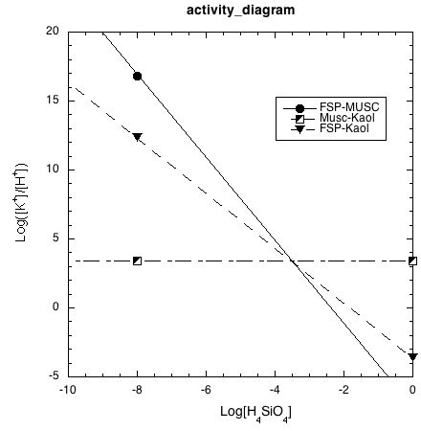

**Finish this off by determining which parts of the 3 reactions are stable and which are metastable.**

**3.** 3) Carbonic acid H2CO3o is very weak, being only partly dissociated under normal pH conditions. Given the following data calculate the concentrations of CO32-, HCO3- and H2CO3o in solution at pH 6 if the total amount of carbonate species is 1molal :-

H2CO3o = HCO3- + H+  logK=-6.35 at 298K

HCO3‑ = CO32- + H+ logK= -10.32

**From the first equilibrium -6.35 = log[HCO3-]+log[H+]-log[H2CO30]**

**At pH6 -0.35= log[HCO3-]- log[H2CO30]**

**Or ;**

**So if we set HCO3- = 1 we get [H2CO3]= 2.237**

**From the second equilibrium -10.32= log[CO32-]- log[HCO3-]+log[H+]**

**At pH6 -4.32= log[CO32-]- log[HCO3-]**

**So, if we set [HCO3-]= 1, [CO32-]=10-4.32= 4.79x10-5**

**Adding all 3 we get 3.238 Molal, so we divide all results by 3.238 to reduce total to 1 Molal**

**Ie [HCO3-]= 0.309M [H2CO30] = 0.691Molal; [CO32-] = 1.48x10-5 M**

4) The reaction

Mg(OH)2 = MgO + H2O

brucite periclase

Has the following thermodynamic properties

HO(1bar) = 63200 J SO = 123.8 J/K

VO (solids) = -1.338 J/bar

Calculate the equilibrium temperature for brucite periclase and water at 1000bar under the following conditions :-

a) All phases pure with water as a perfect gas

b) All phases pure with water having fugacity coefficient of 0.65

c) Solids contain Fe in addition to Mg. Brucite has XMg of 0.95, periclase has XMg of 0.8 , fluid is 75% water. (XH2O=0.75) with a fugacity coefficient of 0.65

**G0=H0-TS0+ (P-1)Vsolids= -RTln K**

$$T=\frac{∆H^{o}+(P-1)∆V_{solids}^{0}}{(ΔS^{0}-RlnK)}$$

For part a) all activities are 1 except H2O for which a=P. And K=P and P=1000

T=932K

b) P=1000, but the gas is now not perfect with fugacity coefficient 0.65

So the activity of H2O is 1000x0.65=650, K=650

T= 884K

c) Now we have activity of MgO of 0.8, activity of Mg(OH)2 of 0.95 and activity of H2O of 1000x0.75x0.65=487.5; K=487.5x0.8/0.95 = 411

T= 838K