Exercise 4
1.Ferric oxides and hydroxides are very insoluble in groundwater. For the reaction:

Fe(OH)₃ +3H⁺ = Fe³⁺ +3H₂O log K= 5.52 at 298 K
Ferric hydroxide

Calculate the equilibrium Fe³⁺ concentration at pH 2 and pH 6
logK=5.52=log[Fe³⁺]-3log[H⁺] given H₂O and Fe(OH)₃ activities of 1.0
5.52-3pH=log[Fe³⁺] at pH2 [Fe²⁺]=10^{-0.48}; at pH6 [Fe²⁺]=10^{-12.48}molal

2. Given the following standard state free energies calculate the pH-pe lines for the reaction:

Fe²⁺ = Fe³⁺ + e⁻
Assume equal amount of Fe²⁺ and Fe³⁺
ΔGº=73300J; Log K= -73300/(2.303x8.314x298)=-12.84

-12.84= Log([Fe³⁺]/[Fe²⁺]) +log [e⁻]; At ferrous/ferric=1

pe=-log[e⁻] = 12.84 independent of pH

And for the reaction involving Fe²⁺ and Fe(OH)₃(solid) and plot them on a pe-pH diagram

Fe²⁺ -90000 J; Fe³⁺ -16700 J; H₂O -237100 J;
Fe(OH)₃ (solid) -696500 J
ΔGº=104800J; Log K= -104800/(2.303x8.314x298)=-18.37
-18.37=3log[H⁺] + log[e⁻]-log[Fe²⁺]; log[Fe²⁺]=-6
-24.37=-3pH-pe; pe=24.37-3pH

Assume equal amount of Fe²⁺ and Fe³⁺ for the first part and 10⁻⁶ M for aqueous species in equilibrium with solid ferric hydroxide. Don’t forget to convert lnK to logK and R=8.314; T=298

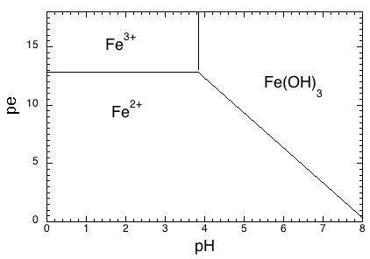

The 3rd reaction between Fe³⁺ and Fe(OH)₃ does not involves electrons so is a vertical line.
3.
6Fe₂SiO₄ + O₂ = 6FeSiO₃ + 2Fe₃O₄
Olivine orthopyroxene spinel

Olivine and orthopyroxene are extremely abundant in most peridotites and both have X_{Fe} of about 0.1. A typical spinel has an activity of Fe₃O₄ of 0.002

ΔHº(1 bar) = -472500J
ΔSº = -169.3 J.K⁻¹
ΔVº(solids)= +0.9 J.bar⁻¹
R=8.314 J.mol⁻¹K⁻¹

Taking standard states of solids as the pure solid at P and T of interest and of gas at 1 bar and T of interest, ΔGº has the volume terms only for the solids

ΔGº = -472500+169.3x1560+0.9(12000-1)=-197593 J

- ΔGº/(2.303x8.314x1560)=6.62=logK=6log(a_{FeSiO3})+2log(a_{Fe3O4})-6log(a_{Fe2SiO4})-log(f_{O2})

a_{FeSiO3}=0.1; a_{Fe2SiO4}= 0.1² and a_{Fe3O4} = 0.002
log(fO2)=-6.62+6x(-1)-12x(-1)-2x2.698 = -6.016 or fO2 = 10^{-6.016} bar

