**First time conference attendance guide – MDSG hints and tips**

**What to expect**

**Attendees**

MDSG is a national conference, and usually has ~100 – 150 people at it. A large number of these (up to 50%) will likely be PhD and masters students, some will be people from the mining industry and the rest will be academics who work in the economic geology field (both faculty and postdocs). Most attendees will be from UK-based companies or institutions, though many will be international students/researchers who work in the UK at the moment, and the conference language is English. Gender balance is usually ~30-40% women.

This year the conference is joint with VMSG (the Volcanic and Magmatic Studies Group), so the total conference numbers will be ~270 with a slightly higher proportion of academic delegates and students than a ‘normal’ MDSG. This will also give you an opportunity to meet a wider range of the UK and Ireland geoscience community.

Everyone will be wearing a name badge giving their name and company/university/institution they work at. MDSG is a friendly community, and very welcoming to students – everyone will be more than happy to chat to you, especially if it is your first conference (see below for more networking tips).

There is an event code of conduct and both MDSG and VMSG take bad behavior (e.g. harassment/discrimination) very seriously. Hopefully it is very unlikely to occur, but if you do witness or experience any unacceptable behaviour please let a member of the organising committee know, or someone from your institution who can raise it in confidence with the conference committee.

**During the event**

You will be emailed a program, but below is an outline of roughly what to expect during the event.

* Most of the event is talks – these are 12 minute presentations where a speaker presents research, followed by 3 minutes for questions from the audience. Anyone can ask a question and students are encouraged to ask questions as well.
* Talks tend to be grouped into ‘sessions’, which are talks on a similar topic (e.g. porphyry deposits). This conference has joint MDSG-VMSG sessions in the morning and then parallel sessions for the rest of the day. Parallel sessions mean talks on different topics will take place in different lecture theatres at the same time, grouped broadly into VMSG and MDSG sessions. Often the program slips a bit so if you wish to switch between sessions partway through to catch a talk bear in mind that the other session may be running late.
* There will be breaks for coffee in the morning, lunch, and tea in the afternoon – food and drink will be provided, so it is only breakfast and dinner on the first day that you will need to buy. These coffee/tea/lunch breaks are good opportunities to ask questions of anyone who gave a talk in the last session and to meet people and network – most people will spend these chatting. These breaks will usually take place where the posters are hung.
* There will be display stands for societies and companies in the poster area as well – this is an opportunity to chat to people from those organisations and they may have job positions
* available, or be promoting their own events or societies.
* There will be an Icebreaker on the first evening. This is a drinks reception, with small snacks. There will be both alcoholic and non-alcoholic drinks available, and there is no obligation to drink if you do not wish to. This is an opportunity to meet people and to network. After the Icebreaker people usually split into smaller groups to go get dinner together in Dublin city center.
* The poster session is in the afternoon of the Monday and Tuesday – this will be ~1.5 hours long and will be accompanied by tea/coffee. During this time you are expected to stand next to your poster (if you are presenting one) and present it to anyone who is interested (see below for tips). The rest of the attendees will circulate the posters and chat to the poster presenters.
* The evening of the 7th is the conference dinner, which will take place in the Guinness storehouse. This will be a buffet meal (dietary requirements are catered for) with alcoholic and non-alcoholic drink options. Usually people go straight from the conference to the dinner so there is no need to dress up (see below for dress code tips). The dinner does not have set seating plans – you will be able to sit at tables to eat and then circulate around the brewery/museum/bars for the evening – and is a good chance to chat to people and have a tasty meal. After the dinner some people will probably continue on to a pub/bar, but there is no pressure to do so, and many do not.
* On the final day there will be talks. There is an AGM (big committee meeting of everyone at the conference) after lunch where the new MDSG committee is voted in. At the end of the day the student prizes for best poster and talk are awarded. Everyone tends to head straight home after the conference which will finish by 3pm on Wednesday 8th (unless you are going to the workshops on the 9th).

**Conference etiquette and dress code**

Conferences are fun and a good chance to hear some exciting science, socialise with your peers, catch up with old friends and make new friends. MDSG is fairly informal and is very student-focused so there will be plenty of younger attendees and plenty of people for whom it will be their first conference. While conferences are a chance to socialise, have fun and relax, they are also professional events, and the economic geology community is a small world so you will probably end up working with at least some of the people you meet at MDSG. There will be alcohol available at social events, however there is no pressure to drink if you do not wish to and there will always be non-alcoholic options. Conferences always have packed schedules so bear in mind the need to be alert the next day when considering your evening plans!

Dress code is smart-casual – most people will wear smart jeans/chinos and shirt or smart top and jacket. I would recommend wearing something smart on the day(s) when you present your poster (i.e. smart top and jacket if you have them), but there is no need to wear a suit or a tie. The days are long and you’ll do a lot of walking and standing around so wear comfy shoes.

I’d recommend bringing a day bag with a bottle of water, notebook and pen (plus whatever else). The lecture theatre should be heated, but you’ll be sitting in it all day and it can get chilly so I’d also recommend bringing a jumper/extra layer.

**Dublin & Ireland tips**

* Dublin is a large capital city with a fairly diverse population and lots of tourists. It is very expensive so budget for food and drink to be similar prices to somewhere like London. There are supermarkets – most Spar shops have a bakery counter if you’re looking for affordable breakfast.
* Ireland uses euros (most places will take card), and the main language is English. The plugs are the same as the UK but the mobile networks are different so you’ll need EU roaming. Cars drive on the left.
* As with any large city, there is street crime and some areas are a bit dodgy so be aware of your surroundings and take the normal precautions you would if out in any large city, particularly if you are walking around after dark. All conference activities are in touristy areas, and the daytime part is on Trinity College campus, which is secure. If you are going back to your hostel or hotel late at night please do not walk on your own – find a conference group going in the same direction, or take a taxi.
* Uber does not work in Dublin – their taxi app is FreeNow, which works exactly the same as Uber. You can also hail taxis in the street if they have their ‘Taxi’ light on.
* There is a good bus and tram (Luas) network in Dublin. There is also the Dart, the overground metro trains, which runs from the airport to the city centre. You need to buy tickets at kiosks or use coins for public transport in Dublin – there is no contactless card payment on buses/trams/trains. You can get a Visitor Leap card (like an Oystercard) for contactless payment – see the conference program for more info.

**Making the most of your time during the conference**

**Preparation – what to do before you go**

* Practice talking through your poster if you are presenting one – come up with a ~3-5 minute talk where you talk someone through your poster and practice doing it in front of people if you can.
* Come up with a 30 second ‘elevator pitch’ (see networking tips below).
* Have a look at the conference program and highlight any talks/posters you are particularly interested in. Maybe print out a copy if you would like a hard copy of the program.
* Also have a quick look at the delegate list and list of people giving talks/posters – see if there is anyone you would particularly like to talk to, or anyone presenting on something similar to you and check out their ResearchGate/Linkedin/work website so you know what they look like and can keep an eye out for them.

**General tips**

* Conferences are fun but can be full on – don’t feel you need to go to everything. You will probably spend the breaks between talk sessions chatting to people about science so it’s fine to take some time out during a talk session – maybe have a look at the program and see if there are any talks you’re less interested in and schedule a potential break for yourself then.
* Take notes during presentations – there will be lots of talks back to back so taking notes is a good way to keep alert and remind yourself of any points you might want to read more about or follow up on. You can also try and think up a question for the speaker.
* Feel free to ask questions, both during the talk question sessions or after a talk during the next break. People enjoy getting feedback on their work and always welcome questions, especially from students.
* You are expected to be quiet during the talks so make sure your phone is on silent. It’s fine to leave or arrive partway through sessions, but try not to stand up in the middle of a talk – wait for the end of the questions.

**Tips for presenting your poster**

* During the poster session you will be expected to stand next to your poster. People will come up to you and usually ask ‘Talk me through it’ or something to that effect – this is the time to give them your prepared 3-5 minute talk through. Also if someone is walking past your poster during the session feel free to ask if they would like you to talk them through it.
* If no one has come round for a while don’t be discouraged, people tend to clump together at poster sessions so you may be standing there waiting for ages then get 5 people at once!
* When you are networking make sure you mention that you’re presenting a poster – advertise it so that you get plenty of people coming to have a look during the poster session.
* If there is someone you are chatting to during one of the breaks who is interested in your work offer to show them your poster, even if it’s not during the poster session – the posters will be up all the time and this is a really good way to showcase your work.
* If there is someone presenting on something you’re interested in, or you see a name on the delegate list you would like to get feedback from try and find them during the Icebreaker/coffee breaks and ask if they would like to see your poster at some point. Everyone is very friendly and willing to give feedback to students.
* Write down any useful comments or feedback you got during the poster session in your notebook before you forget it, along with the names of anyone who was particularly interested/helpful. This feedback is invaluable for helping guide writing your papers/thesis and giving some idea what reviewers/examiners might pick up on. It’s also a good way to scout potential reviewers.
* There is a prize for the best student poster – the judges are anonymous and will be circulating during the poster session.

**Tips for networking**

* People go to conferences to network so don’t feel self-conscious introducing yourself to somebody new. Everyone is very friendly and welcoming, and we all remember when we didn’t know anyone in the community, so people will be more than happy to chat.
* If you enjoyed a talk or poster go up to the presenter and tell them, they’ll appreciate it and it’s a good conversation starter. Coffee/lunch/tea breaks are also a good opportunity to ask questions if you didn’t get the chance during the presentation or if there was something you didn’t quite understand about someone’s talk.
* Look out for anyone who is working in your field (have a look at the program to see who else is presenting) and introduce yourself. Be aware that you also won’t get the chance to speak to everybody so don’t worry if you don’t get the chance to chat to everyone you wanted to.
* Come up with a 30 second elevator pitch for when you introduce yourself to someone. Most conversations will start with “What do you do/research?” so have an answer prepared. An elevator pitch would normally contain your name, what you are working on and something exciting from your project, that you’re presenting a poster +/- what you want to get out of the conference (e.g. “My name is Katie, I’m a lecturer at UCL researching critical metals, in particular how magmatic-hydrothermal processes partition metals – turns out semi-metals are really important for precious metal mobility. If you’re interested I’m giving a talk on Friday and I’m hoping to build some new collaborations during the conference.”).

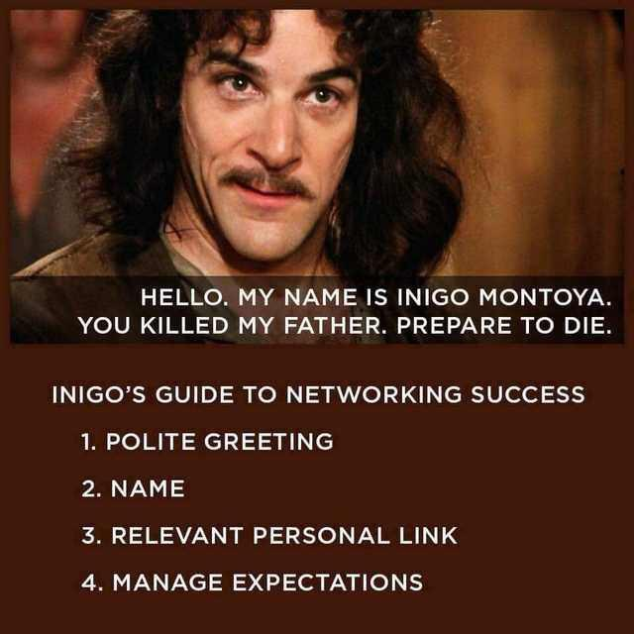

*For any of you who are a Princess Bride fan!*

* Chatting about science every waking minute can be exhausting so also feel free to take a break and a bit of you time if it gets a bit much!
* Follow up emails – after the conference send a short, polite email to anyone you wanted to follow up with. For example: “Hi Jamie, we met at MDSG. I really enjoyed your talk on porphyry copper deposits and it was great chatting about fertility vectors – I would be interested in finding out more about that postdoc position you mentioned. Best wishes, Katie McFall.”.

Most of all, have fun and enjoy the conference 😊