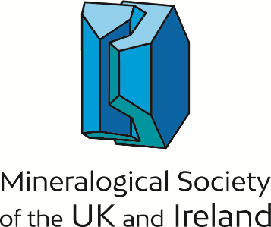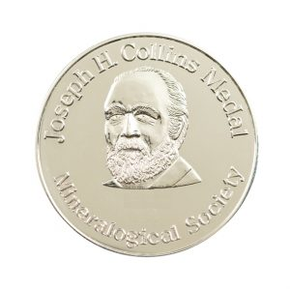

Nomination form for Mineralogical Society Awards

Collins Medal

Purpose
‘The Collins medal will be awarded annually to a scientist who, during a long and active career, has made an outstanding contribution to pure or applied aspects of Mineral Sciences and Associated Studies. This award for senior scientists will recognize scientific excellence in mineralogy and its applications; mineralogy being broadly defined and reflecting the diverse and worldwide interests and membership of the Society with its various specialist groups. Evidence of such excellence should be in the form of the impact of the applicant’s/nominee’s work, their publications, service to industry, outreach/promotion of science, leadership or other service to the community, teaching and work to improve equality, diversity and inclusivity in our science. Nominees/applicants do not have to be Members of the Mineralogical Society or nationals of the UK or Ireland.

Eligibility
If you feel that there are any personal circumstances which you wish to be taken into consideration when evaluating your nomination (e.g. caring responsibilities, periods of family leave, bereavement, ill health or disability), please give details of their impact on your/the nominee’s career.

Nominations should consist of a completed form (written in the third person, in order that self-nominations and third-party nominations cannot be distinguished by the committee) and a copy of the nominee’s CV. Nominations by two or more nominators are welcome.

Nominations will remain on the table for three years. Previous recipients of the award, Society Officers, members of Council and members of the Committee (at the time of nomination and adjudication) will not be eligible for the award.

Name of nominee/applicant:

Name of nominee/applicant:
Address:
E-mail address:

Names of nominator(s):

Signature(s):

A. Describe the impact of the applicant’s/nominee’s work (this will help to summarize the effect of the work of the applicant/nominee under the categories described in the rest of the form) (250 words)

B. List 5 key publication (feel free to include information about downloads/citations here) (250 words)

C. Service to Industry (250 words)

D. Outreach/promotion of our science (250 words

E. Leadership or other service to the community (250 words)

F. Teaching (250 words)
G. Work to improve Equality, Diversity and Inclusivity in our science (250 words)

I certify that, to the best of my knowledge, the person I have nominated has not been sanctioned or found at fault as the result of a complaint, investigation, or other proceeding related to their professional conduct (including harassment allegations), and that they are not currently the subject of such an investigation.
I am aware that the person I have nominated has been sanctioned or found at fault as the result of a complaint, investigation, or other proceeding related to their professional conduct, or that they are is currently the subject of such an investigation but would nevertheless like to proceed with the nomination. (Please note that selecting the second case is not necessarily disqualifying, but you may be contacted for a confidential discussion.)

