Mineralogical Society at 150: Past Discoveries and Future Frontiers
23-25 June 2026
REPORT

CONFERENCE
We gathered in a baking hot Manchester in late June 2026 to celebrate the Society’s 150th birthday. During his presidency, Prof. Bruce Yardley had introduced us to the term “sesquicentennial”! All of our Special Interest Groups along with our friends in the Mineral Deposits Studies Group climbed aboard the good ship MinSoc-150 and we set sail. And what a celebration!
For our conference, we chose a range of session titles to reflect our science in the 21st century but which also offered the opportunity to reflect on historical aspects. These sessions were led by those in our special interest groups and their names are given below. We included our usual ‘universal’ session for those who wished to present work which didn’t quite fit into any of our other categories. Key in all our discussions was the decision that students and early-career researchers should be involved in all aspects of the conference including as session leaders, as keynote speakers and as regular speakers. (It would have been an easy [but incorrect] decision to focus on the heroes of our subject for this event.)
The list of sessions and convenors was as follows:
Session 1: Universal: Mineralogy: then, now and beyond
H. Pendlowski (The James Hutton Institute, Aberdeen), Ralf Gertisser (Keele University)
Session 2: Biogeochemical impacts on mineral cycling in natural and engineered systems
John Moreau (Glasgow), Casey Bryce (University of Bristol), Jon Lloyd (University of Manchester
Session 3: Minerals, Contaminant Dynamics and Remediation in the Environment
L. Townsend (Nuclear Waste Services, UK), A. Neumann (Paul Scherrer Institute, Switzerland), K. Rothwell (Stirling University)
Session 4: Minerals for a Sustainable Environment
John MacDonald (University of Glasgow), David McNamara (University of Liverpool), Faisal Khudhur (University of Edinburgh)
Session 5: Engineered minerals for Existing and emerging technologies
Conveners: Rick Kimber (University of Manchester), Kirill Shafran (BYK Additives, UK), Chris Egan-Morriss (University of Manchester)
Session 6: Critical Minerals and Energy Transition
Martin Smith (University of Brighton), Hannah Grant (British Geological Survey), Adrian Finch (University of St. Andrews), Holly Elliott (British Geological Survey)
Session 7: Evolving Mineralogy of the Earth System: Interactions within the Crust, Mantle and Core
Conveners: Alfred Wilson (University of Leeds), Fred Richards (Imperial College London), Simon Hunt, Tara McElhinny and Josh Littleton (University of Manchester), Ollie Lord (University of Bristol)
Session 8: Crystal records of volcanic, magmatic and mineralisation processes
Conveners: Mike Stock (Trinity College Dublin), Steven Hollis (University of Edinburgh), David Neave (University of Manchester), Owen Weller (University of Cambridge)
Session 9: Metamorphism and Fluid-Melt-Rock interactions within the lithosphere
Richard Palin (University of Oxford), Richard White (University of St Andrews), Charlotte Simpson (University of Oxford)
Session 10: Advances in Mineralogical Analysis – Development of Techniques for 21st Century Research
George Cooper (Cardiff University), J.F.W. Bowles (Private) and Marie-Laure Bagard (University of Cambridge)
Between the 10 sessions, we had 176 presentations (including posters), a tall order over a three-day meeting. Also included in the programme were plenary lectures by Helen Williams (Hallimond Lecture - Searching for Earth’s missing magma oceans), Jocelyne Brendlé (George Brown Lecture – ‘Clay-Based Stimuli-Responsive Materials: A Versatile Platform for Smart Functional Systems’) and Andrew Berry (Neumann medallist – Research on the Edge).
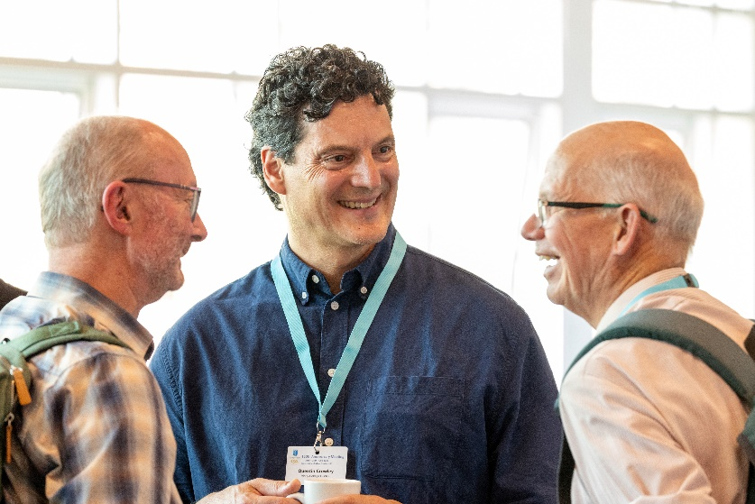
John Wheeler, Quentin Crowley and Dave Waters enjoying the ice-breaker reception.
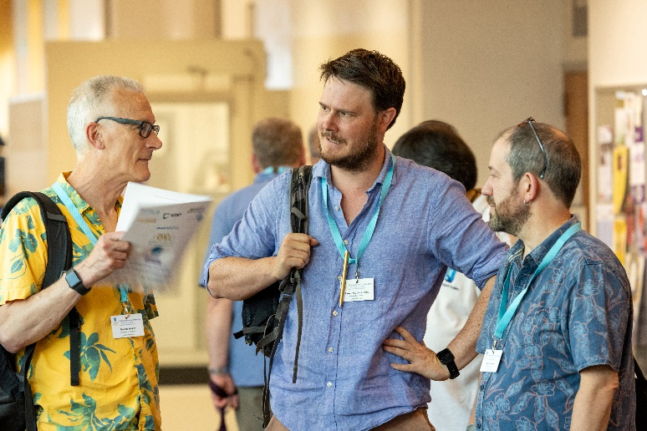
Gawen Jenkin, Sam Broom-Fendley and Martin Smith.

SPONSORS
We began our gathering with an ice-breaker reception the evening of Monday 22nd June. Cold drinks were the order of the day as the outside (and inside) temperatures exceeded 30°C. It was great to meet friends old and new in a relaxed environment and it was gratifying to welcome sponsors/exhibitors of our event (Rigaku, Elemental Scientific, Renishaw, BlueScientific and Jeol).
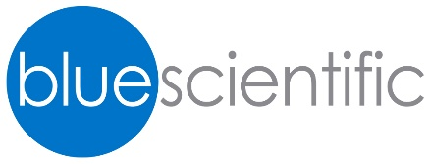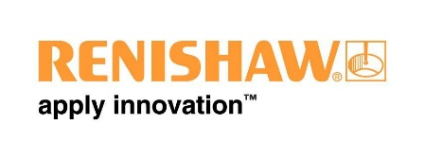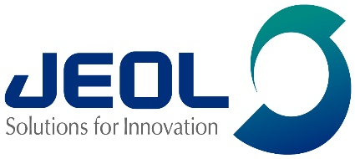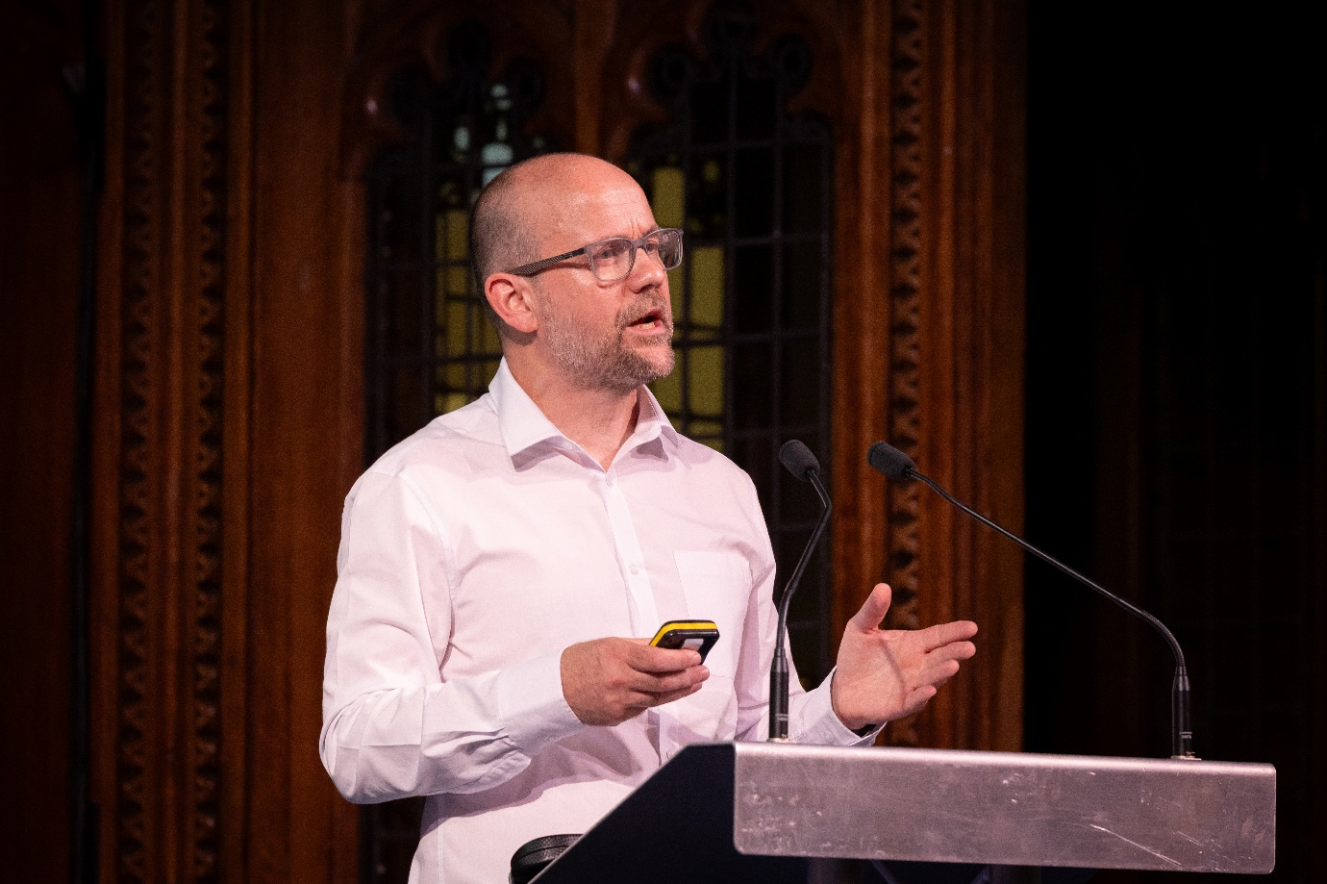
On the following morning, President and meeting host, Prof. Sam Shaw, welcomed our delegates, both those attending in person and those joining remotely. We also had a message of welcome and celebration from our vice-President, Prof. Chun Hui Zhou, unable to join us in person. This is available to view on YouTube (https://youtu.be/7OxtjfKmVZo?si=JCZNndl1WYk8xNt8).
We fulfilled the Society’s ambition to make all of its meetings and conferences hybrid and offered at zero or very reduced cost to those without the means or ability to attend in person. After messages from our sponsors, we began the programme in earnest. The programme had three plenary lectures with four parallel sessions on Tuesday and three each on Wednesday and Thursday. The full programme is available here (https://www.minersoc.org/wp-content/uploads/2026/07/MinSoc-150-Programme-Final.pdf); there were many, many highlights in our three-day programme with many expressing enjoyment of the variety on offer.

HISTORY
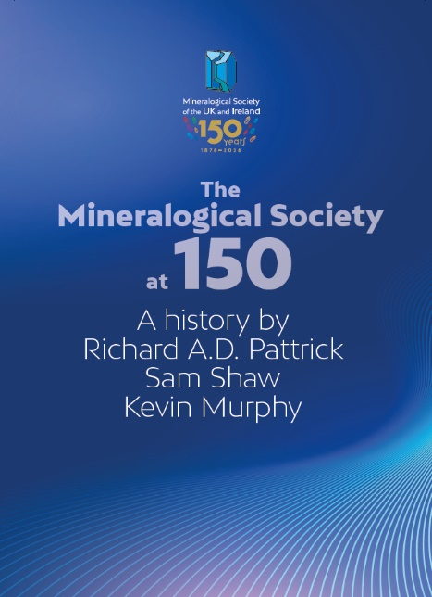
The other main feature of our celebration was publication of our 150 year history. This was managed largely by former President, Prof. Richard Pattrick, aided and abetted by Sam Shaw and Kevin Murphy with contributions by many others including staff members and former officers, members of council and others who helped with specific contributions throughout the document. The authors met three times in London to pore over archive documents which stretch back to the foundation of the Society. We included in the document many images not seen widely beyond their original publication in the journal. A couple of features we included were: (1) brief histories of so-called ‘heroes’ of the Society, those who were instrumental in its establishment, those who led it through periods of significant change and those who served for extended periods of time; (2) the evolution of analytical techniques in our science; (3) a timeline for the growth of the Society with focus on major developments over time; and (4) we tried to include as much photographic and graphical information as we could to illustrate the document and to show members what our founders actually looked like. The history was set against the back-drop of major events in history and how they impacted Society activity. This was also reflected in the piece about the Society’s finances over the past 150 years; where the Society got its money and how it spent it. Clearly the journals have been a major focus for Society income/expenditure throughout our history.
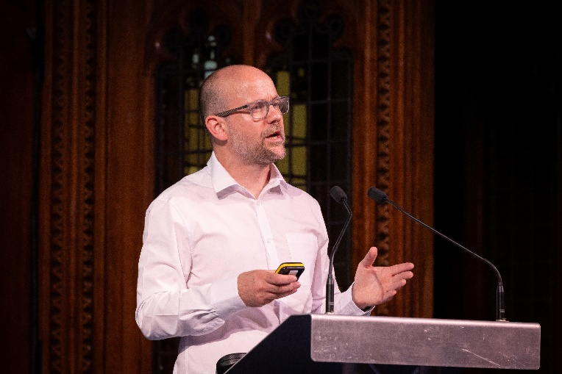
Sam Shaw made a summary presentation of the Society’s History after the banquet held on the evening of 23rd June in the magnificent Whitworth Hall.

BANQUET
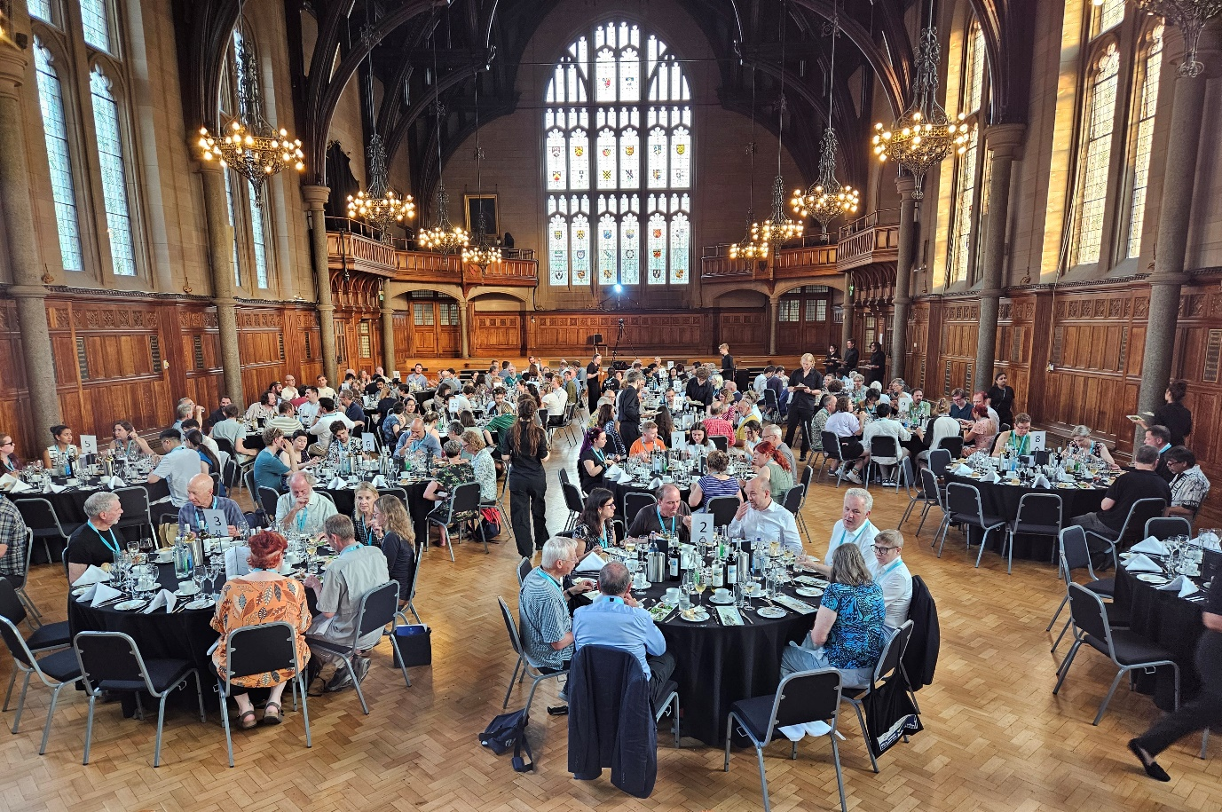
Crystalis Colloquia Celebramus!
This history will be published by end-2026 in Mineralogical Magazine and linked from our other journals.

JOURNALS
We have already received offers of numerous papers for a themed collection of papers for publication in Mineralogical Magazine. Editors Stuart Mills (pictured) and Roger Mitchell are keen to receive more to really reflect the breadth of the Society’s work.
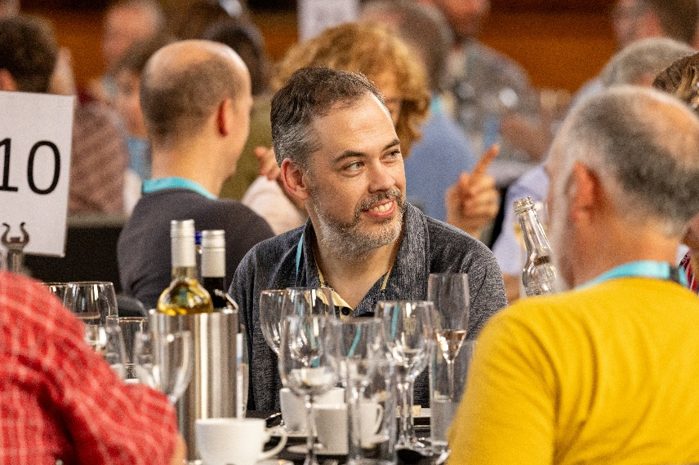
We were honoured that friends from related Societies and international bodies attended to offer kind words about our Society during the banquet. These included Bob Bodnar and Ann Benbow, President and Executive Director, respectively, of the Mineralogical Society of America, Hilary Downes, vice-President of EMU, Mercedez Suarez (President, Association Internationale Pour l’Etude des Argiles), and Chiara Petrone (vice-President of the Geological Society of London). Our links have always been strong and we will place their gifts in prominent positions at our office in Twickenham.
The Society also took the opportunity to make presentations to two of its staff, Russell Rajendra and Kevin Murphy. The Lifetime achievement awards were welcomed warmly by those in attendance.

MEDALLISTS’ DINNER
On the evening of the second day of the conference, there was an additional special dinner, organized by Ed and Priscilla Grew. This was an occasion to honour our medallists past and present (including Ed) and indeed to reflect on those who are no longer with us. Neither Ed nor Priscilla was able to join us for the conference or the banquet so it was especially generous of them.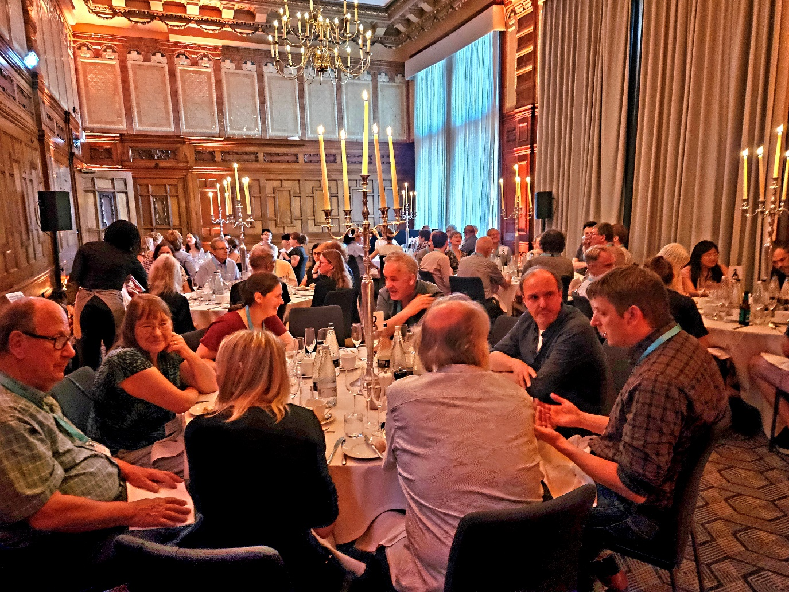
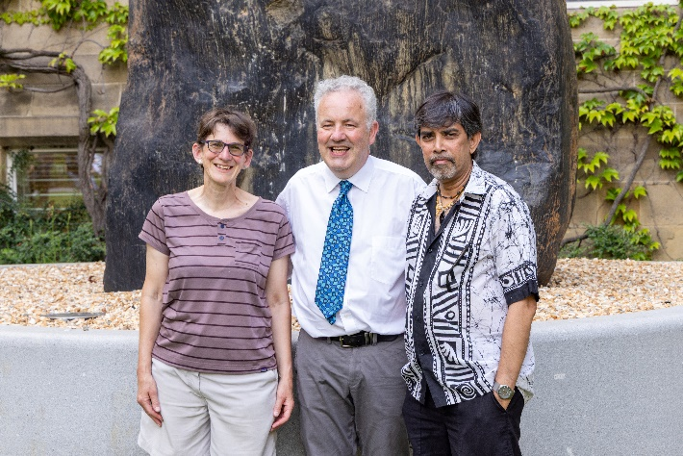
Society Staff: Helen Kerbey, Kevin Murphy and Russell Rajendra.
AWARDS
During the awards ceremony held on Thursday afternoon, chaired once again by Sam Shaw, the following awards were made:
Student Presentation Prizes to
Oral: Flora Reid (University of Manchester), A. Tanciongco (University of Leicester)
Poster: Careen MacRae (University of Edinburgh), Andie Bryce (University of Strathclyde)
These prizes were coordinated by Helen Kerbey, Urmi Ghosh and Ralf Gertisser.
Hallimond lecture certificate: to Prof. Helen Williams
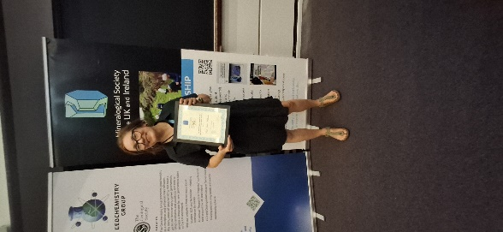

George Brown Lecture Certificate: to Prof. Jocelyne Brendlé
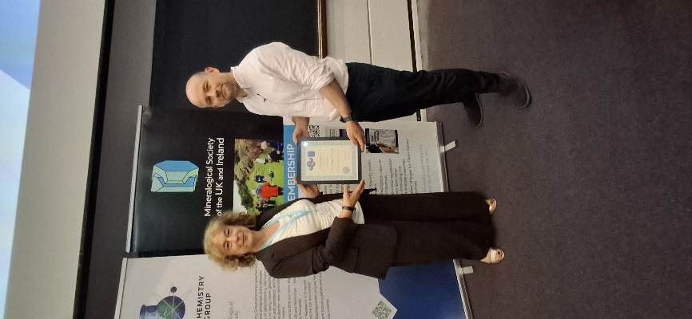

Collins Medal: to Prof. Barb Dutrow
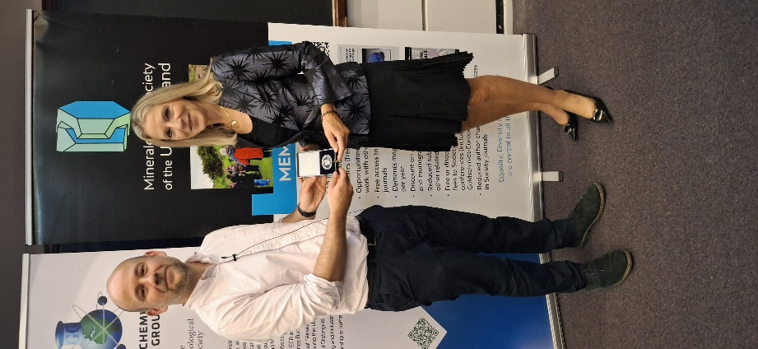
Hey Medal: to Dr Lin Ma
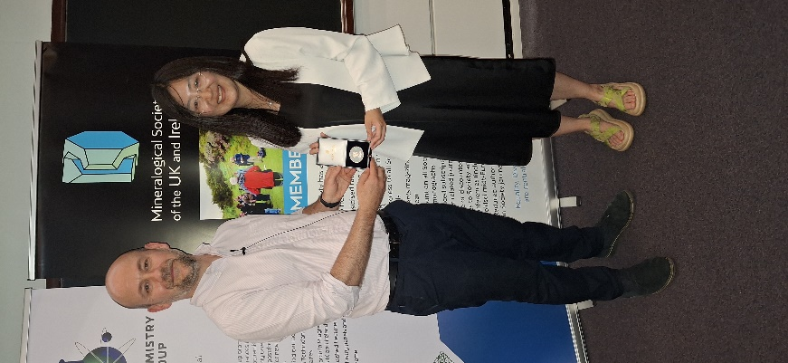
Neumann Medal: to Andrew Berry
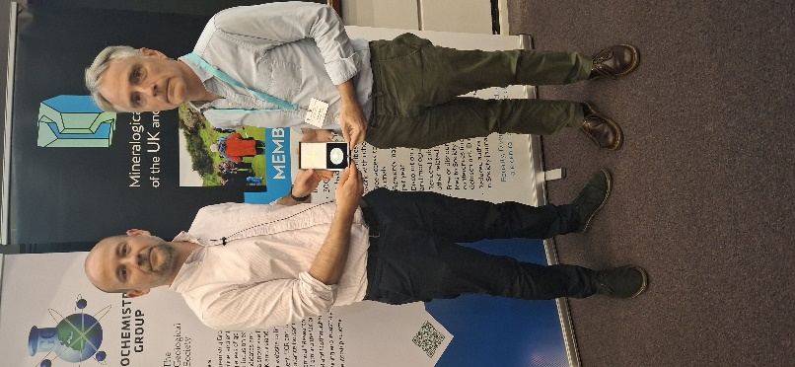
Howie Award for Best paper: Dr James Byrne
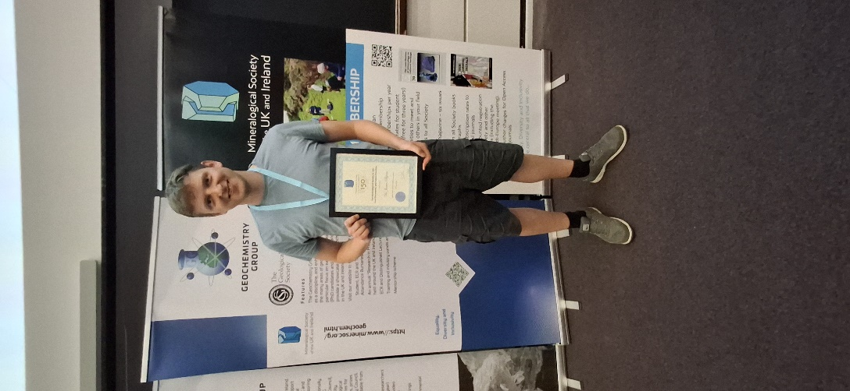
In time-honoured fashion, we took a group photo of those who attended the conference for the archives.
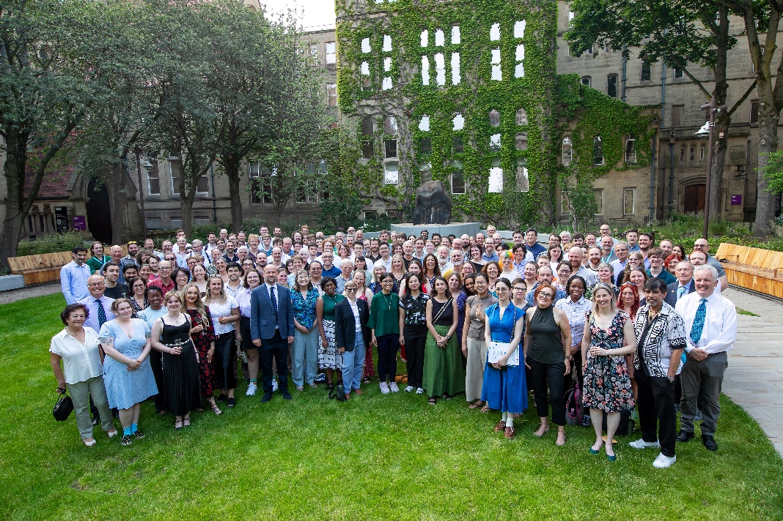
So, we look forward to our next birthday, and many more to come, especially if we can share it with as many friends and colleagues as we did this year.

S. Shaw, K. Murphy

